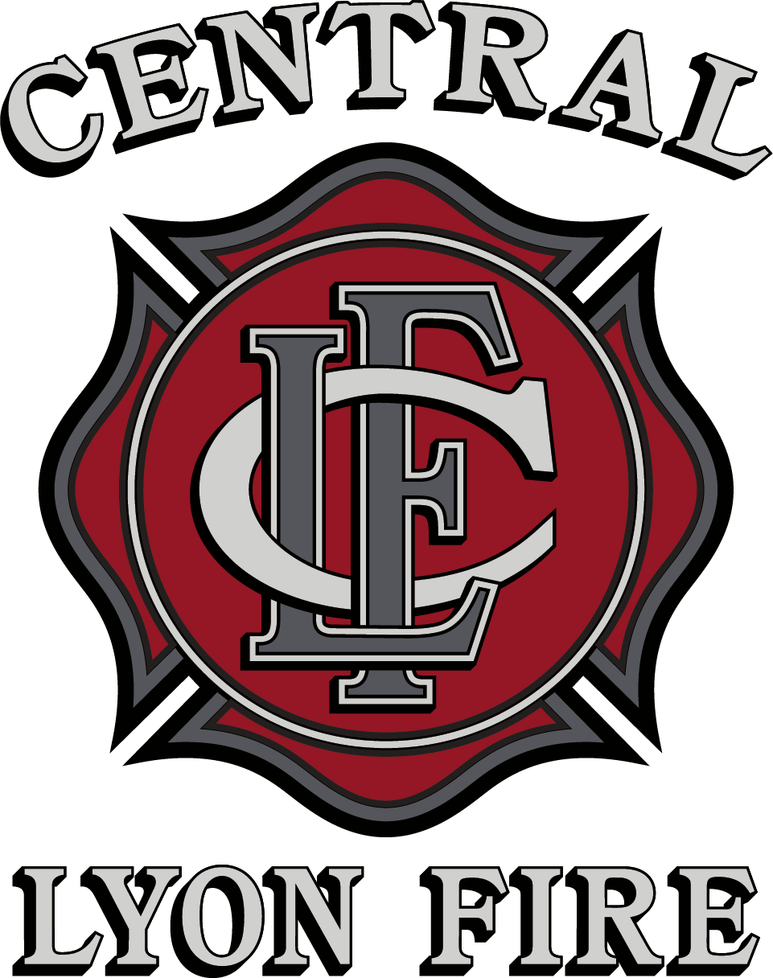
246 Dayton Valley Rd, Ste 106
Dayton, NV 89403
(775) 246-6209

Volunteer Application

An Equal Opportunity Employer
COMPLETE ALL SECTIONS. INCOMPLETE APPLICATIONS WILL NOT BE ACCEPTED
If you have a disability and believe you require accommodation for the disability during the selection
process, please contact us to make appropriate arrangements.

Name: Date:

Mailing Address:

Physical Address:

City: State: Zip Code:

Telephone: Home: ( ) Work: ( )

Cell Phone: ( )

E-mail Address:

May we contact you at work? Yes No

Emergency Contact Information:

Name: ___________________________________ Relation: ________________________ Phone #: ____________

______________________________________________________________________________

EDUCATION RECORD:

Please attach copies of applicable certifications.

Did you graduate from high school or receive a GED certificate? Yes No School Name:
 | Name of School | Credits/Hours | Type of Degree/Certificate
Business/Technical/Vocational

High School |  | n/a
College/University

Graduate School

LICENSES AND CERTIFICATIONS:

List driver's license and other current licenses, certifications, or registrations required for the position for which you are applying. Indicate types, state license numbers, and expiration dates. Attach a copy of current driver’s license and DMV printout. INCOMPLETE APPLICATIONS WILL NOT BE CONSIDERED

List any special skills you possess and/or equipment or office machines you can operate.

OTHER INFORMATION:

Have you previously been a member of the Central Lyon County Fire Protection District?
Yes No When?

Have you ever been convicted of a felony or any lesser crime, other than a minor traffic infraction? Yes No A conviction or guilty plea will not necessarily disqualify you from volunteer work with CLCFD. If yes, list all such offenses and provide date, name of court, and disposition.

Have you ever been disciplined in your employment related to workplace violence? Yes No If yes, please explain:

Do you presently use illegal drugs? Yes No

Are you currently employed by Central Lyon County Fire District in any capacity? Yes No
If yes, what department? _____________________ Job Title_____________________________

Have you been given a description or had the requirements of the volunteer work explained to you Yes No

Do you understand these requirements? Yes No

HISTORY OF VOLUNTEER ACTIVITIES AND PAID EMPLOYMENT:

Provide information regarding paid, military, and volunteer work which may be related to the position for which you are applying. Describe your most recent experience first; then list other relevant positions in chronological order, working down from the most recent. It is only necessary to list volunteer work, training, employment, or military service which relates to the activities for which you are offering to volunteer. Use additional sheets if necessary.

Organization: Position:

Address: From (Mo./Yr.) To (Mo./Yr.)

City, State, Zip: Hours per week Paid or Volunteer

Supervisor’s Name/Title: Telephone:

Paid or Volunteer Assignments:

Reason for Leaving:

Organization: Position:

Address: From (Mo./Yr.) To (Mo./Yr.)

City, State, Zip: Hours per week Paid or Volunteer

Supervisor’s Name/Title: Telephone:

Paid or Volunteer Assignments:

Reason for Leaving:

Organization: Position:

Address: From (Mo./Yr.) To (Mo./Yr.)

City, State, Zip: Hours per week Paid or Volunteer

Supervisor’s Name/Title: Telephone:

Paid or Volunteer Assignments:

Reason for Leaving:

Organization: Position:

Address: From (Mo./Yr.) To (Mo./Yr.)

City, State, Zip: Hours per week Paid or Volunteer

Supervisor’s Name/Title: Telephone:

Paid or Volunteer Assignments:

Reason for Leaving:

May Central Lyon County Fire District contact all employers listed? Yes No

Please state below any other information that would be helpful in determining your qualifications for the volunteer activities. You may include significant accomplishments, previous career highlights, or any other information that is not included in this volunteer application.

ACKNOWLEDGMENTS:

Please READ ALL of the following statements and INITIAL EACH of the lines to indicate you have read and understand each of the statements. If you have questions, contact the Fire District Office.
____ To qualify for volunteer employment, applicants must be at least 18 years of age unless otherwise specified in the job announcement. If offered a position as a volunteer, can you furnish proof of age? Yes No
____ This is not an application for a paid position. Application for paid positions must be made on a separate application form.
____ I authorize Central Lyon County Fire District to contact any employer or individual that I have listed on my volunteer application and/or résumé or mentioned in job interviews, and to obtain from them any relevant information regarding my previous employment, volunteer services, education, certificates, licenses, military service, criminal history, characteristics or traits, or other qualifications for volunteering with Central Lyon County Fire District.

____ In exchange for Central Lyon County Fire Districts consideration of my volunteer application, I authorize anyone possessing this information to furnish it to Central Lyon County Fire District upon request, and I release the individual company or institution and all individuals providing the information or acquiring the information, including Central Lyon County Fire District, from all claims, liability, and damages whatsoever in furnishing, obtaining, or using said information including, but not limited to, claims for defamation, libel, slander, infliction of emotional distress, and interference with current or prospective economic relations.

____ I declare that I am offering to volunteer to provide services for civic, charitable, or humanitarian reasons and am doing so freely and without coercion, direct or implied, from Central Lyon County Fire District. I recognize that I will not receive nor do I expect compensation for the services I am offering, other than possible nominal fees, paid expenses, or reasonable benefits which may be provided to me at the sole discretion of Central Lyon County Fire District for performing the offered services. It is not my purpose or my expectation that my services are in preparation for employment with Central Lyon County Fire District.

The facts set forth in my volunteer application are true and complete. I understand that if asked to volunteer, any false statement on this application may result in my dismissal.

Signature of Applicant: __________________________________ Date: _______________________

Signature of Station Chief: _______________________________ Date: ________________________

Signature of District Chief: _______________________________Date: ________________________

“Central Lyon County Fire District is an equal opportunity provider”

